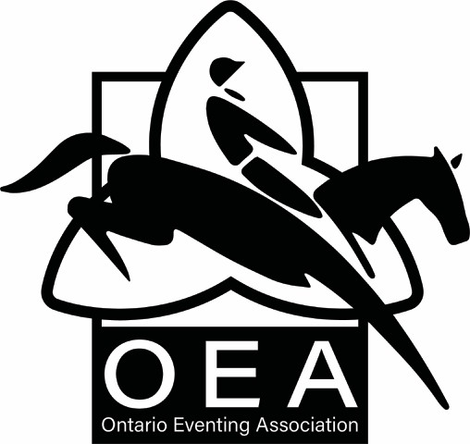

ONTARIO EVENTING ASSOCIATION ORGANIZER’S DAY MEMBERSHIP REPORTING FORM

**Name and Date of Horse Trial**:

|  |  |  |  |  |
| --- | --- | --- | --- | --- |
| **Day Competitors Name** | **Level** | **Day Fee** | **Event Org. Adm. Fee** | **OHTA**  **Portion** |
|  |  | $15.00 | $5.00 | $10.00 |
|  |  |  |  |  |
|  |  |  |  |  |
|  |  |  |  |  |
|  |  |  |  |  |
|  |  |  |  |  |
|  |  |  |  |  |
|  |  |  |  |  |
|  |  |  |  |  |
|  |  |  |  |  |
|  |  |  |  |  |
|  |  |  |  |  |
|  |  |  |  |  |
|  |  |  |  |  |
|  |  |  |  |  |
|  |  |  |  |  |
|  |  |  |  |  |
|  |  |  |  |  |

**Total $**

Please return this form within **14 days** of your competition, along with Day Membership Forms and Fees (payable to OEA) minus $5.00 Event Organizers Administration Fee for each competitor to:

Bernadette Johnston – [finances@ontarioeventing.ca](mailto:finances@ontarioeventing.ca)